US Cellular
Talend 8.0

Document Information
This document provides the details of common troubleshooting in Talend 8.0
Document Edit History
Version | Date | Additions/Modifications | Prepared/Revised by
0.1 |  | Draft | P.Sarath
0.2 |  | Revised & Final | P.Sarath

- When trying to open a workspace, users were getting the below error

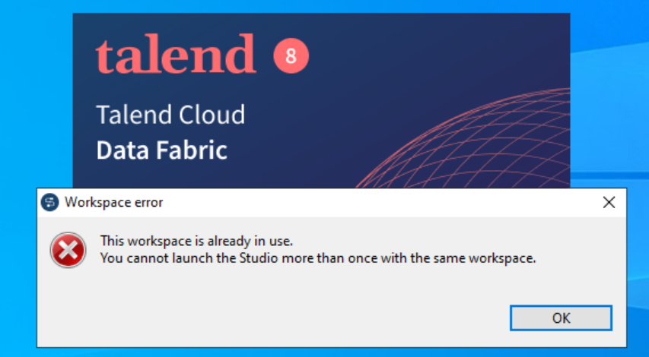
Explanation-
Users would need to do the following to avoid this:
- Create a new folder inside the Talend Installation which is D:\Talend_8.0\ with their preferred name (Like Talend Workspace or Workspace_1 etc.) other than the already existing name.

- Add details on placement of the patch in the patches folder
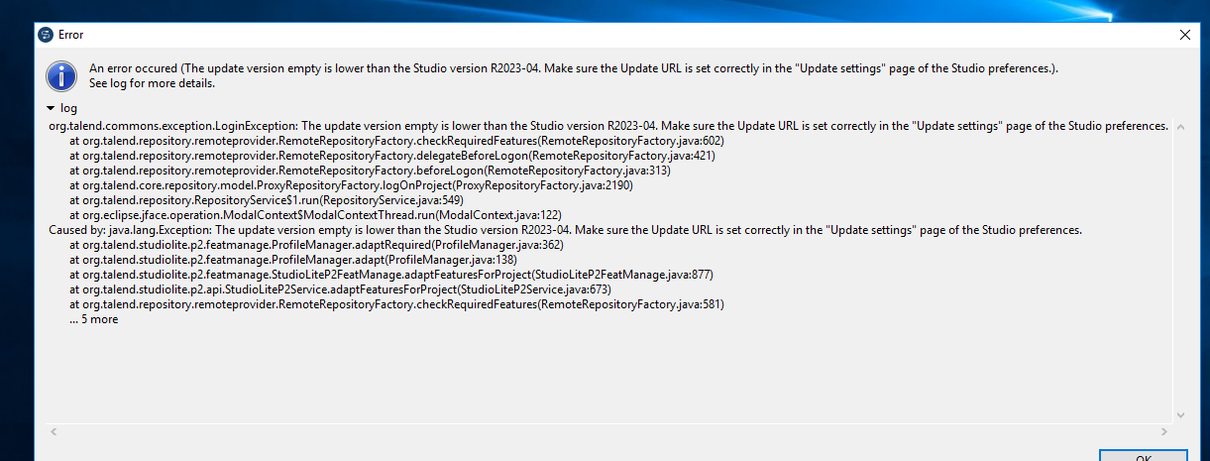

Explanation
- While creating a connection to the TMC from studio, developers need to follow below steps: developers need to go to the Preferences àUpdate Settings à Click on Restore Defaults à Check on the Update from local settings à Hit Apply and close. This ensures that studio is taking the patch from local patches folder and not from TMC directly

- Go to the Preferences
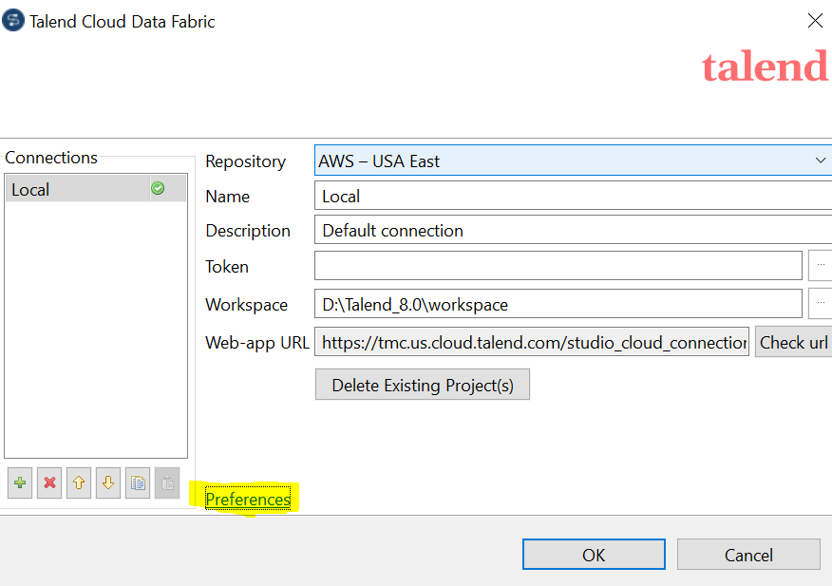

- Go to Update Settings
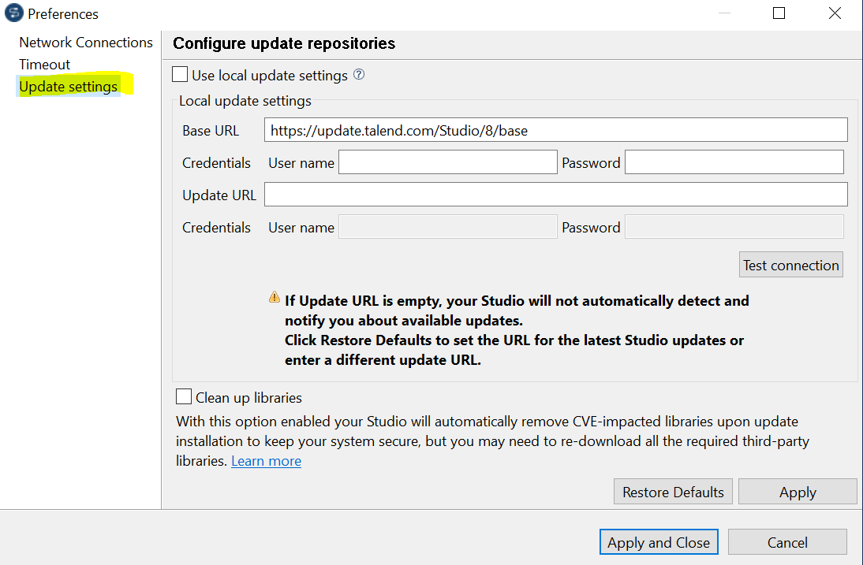

- Click on Restore Defaults. Then check on the Update from local settings and click on Hit Apply and close.

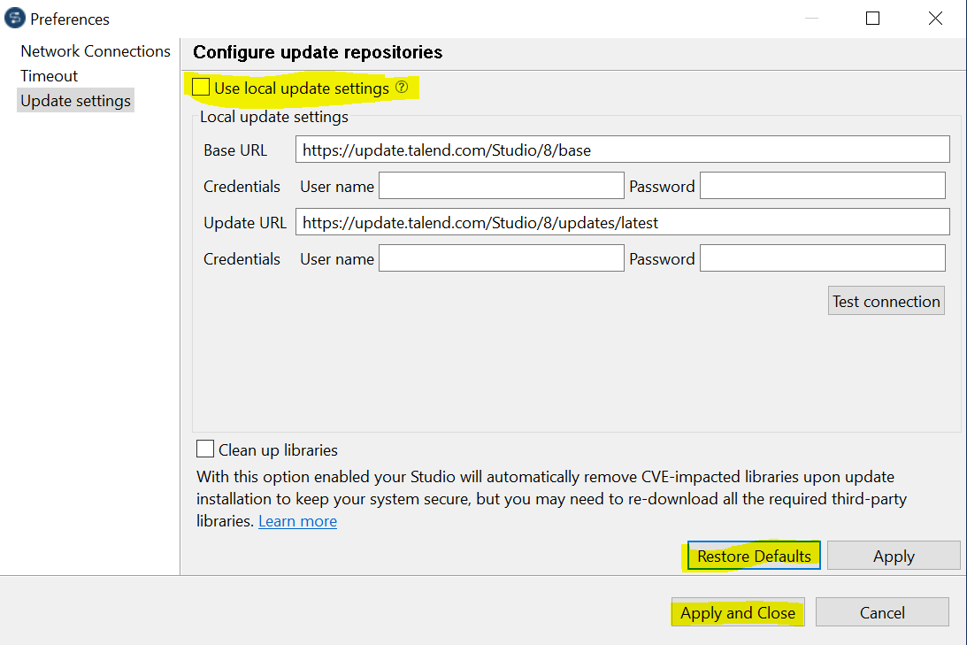

- How to switch between JDK versions in Talend 8.0

Once connected to the repository, click on edit profile. Click on General and then Java. Click on java version. Select the check box for “Enable Java 17 compatibility”. Click on Apply and Close.

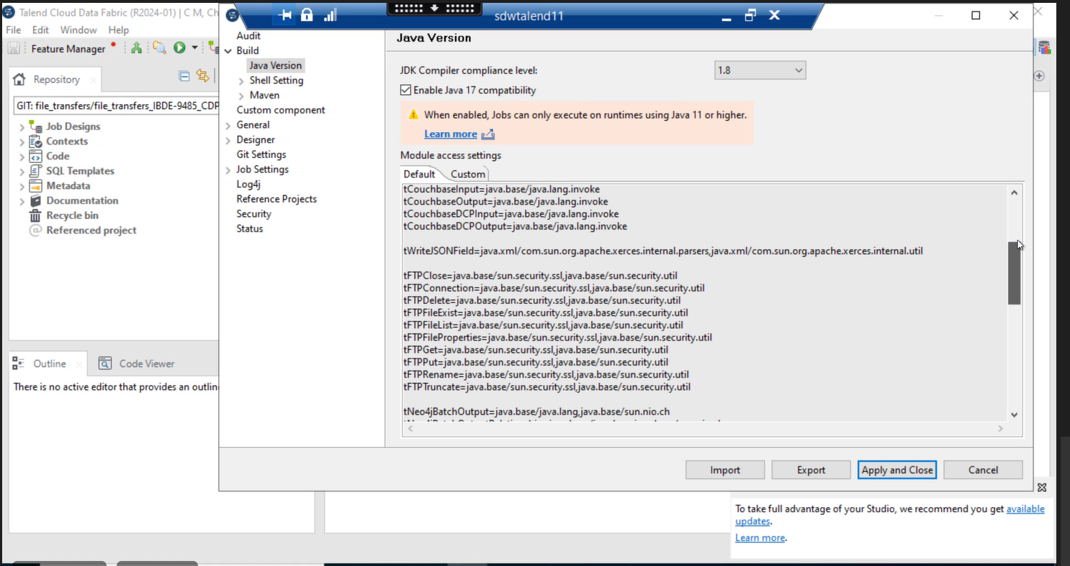

Troubleshooting while CDP upgrade:
As part of cdp upgrade we had faced few below issues:
- 09HDFS write is failing at A new KMS certificate handshake. While there are Truststore variables defined and the jsscacerts certificate defined, the handshake is not able to take the certificate:
Resolution- added tsetkeystore in the job.
- jfrog artifactory jobs failed with below error.Caused by: org.apache.hive.service.cli.HiveSQLException: Error while processing statement: Cannot modify mapred.job.name at runtime. It is not in list of params that are allowed to be modified at runtime.
Resolution: pointed the CDP version to 7.1.7.2030-7 and commented the hive properties in Jenkins.
- Jobs failed with “Exception in thread "main" java.lang.NoClassDefFoundError: com/google/common/util/concurrent/internal/InternalFutureFailureAccess” :
Resolution: added mvn:com.google.guava/failureaccess/1.0.1/jar
- QA builds failed with “Exception in thread "main" java.lang.NoClassDefFoundError: com/google/common/util/concurrent/internal/InternalFutureFailureAccess”
Whereas DEV builds succeeded.
Resolution: This was Sync issue, after adding mvn:com.google.guava/failureaccess/1.0.1/jar

All the jobs in Talend had to be opened, pushed the code to remote again.
====================================================================
Talend 8.0 installation error
Error: Dynamic Distribution Setting is missing in the studio 8 which is present in 7.3, due to this we are unable to run the jobs with HDFS/HIVE components
PFB the screenshot for the error:
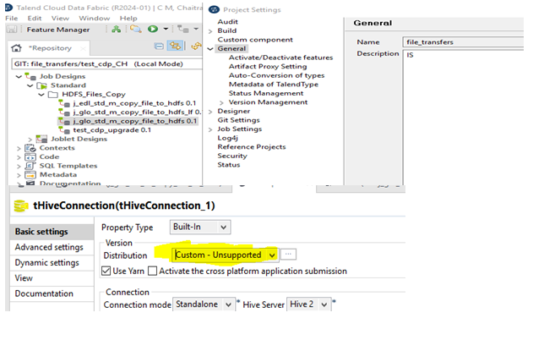
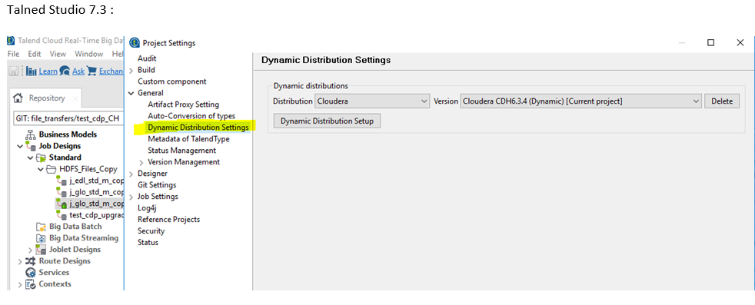
“Dynamic Distribution Settings option” is now replaced with new option to Activate/Deactivate features in which we can add CDP distribution.

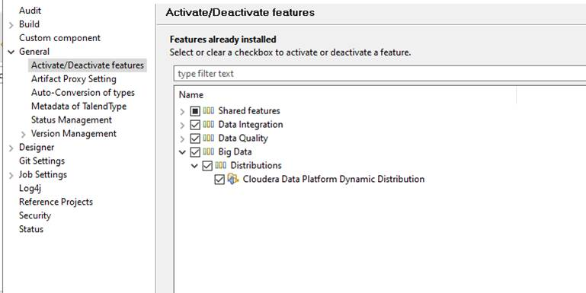

Added the Cloudera data platform dynamic distribution feature and tested successfully.

Solution: -
Below mentioned option was checked by default in Talend 8.0, the same was unchecked in 7.3.
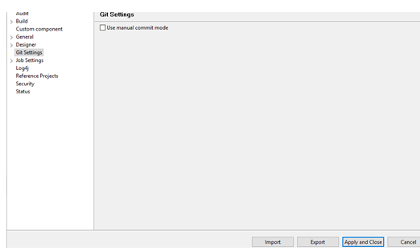
In 8.0 if this checkbox is selected, the code is automatically pushed to Git and if we wish to commit, then a Talend Staging View would be available for the users wherein they’ve to manually select the Unstaged Changes à Add an Index à Push the same to Staged Changes à Add a commit message & commit à Push to Git, as per below screenshot
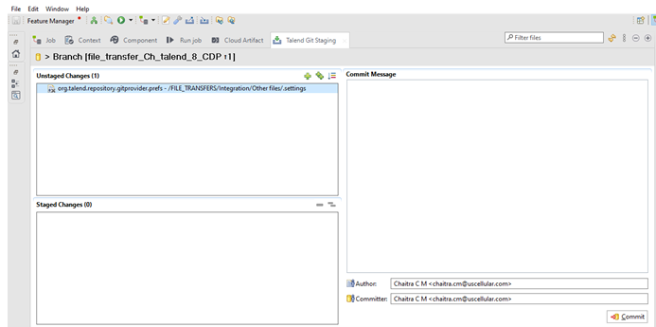

Normal Operating Procedure:

Monitoring:

Nimsoft is the monitoring tool that we have in place for Talend applications. Below are the details on the metrics that is being monitored:
- Talend Remote Engine Process – Across all Talend Servers. If this process goes down, there should be an alert sent for the same.

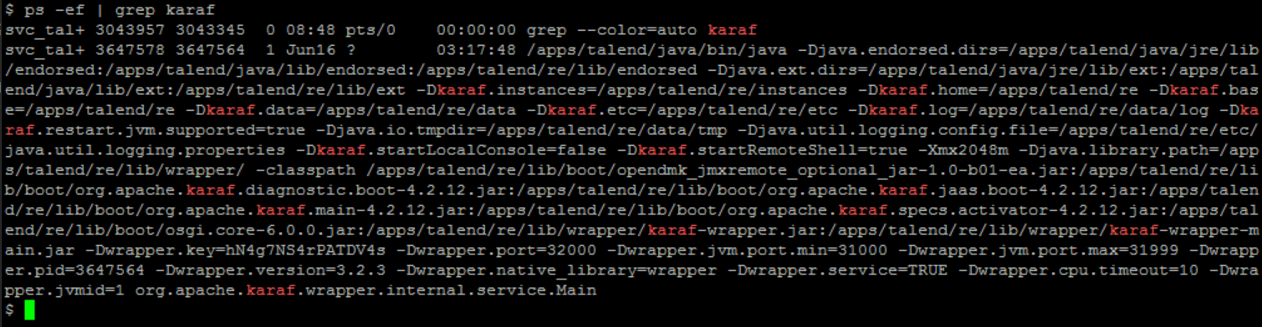

- File beat Process – Only on the ELK Server. If this process goes down, there should be an alert sent for the same.

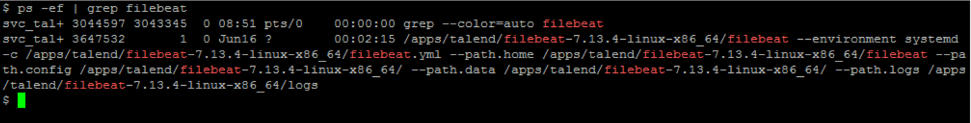

- ActiveMQ broker server for the ESB – Only on the Active MQ(Message Queue) server. If this process goes down, there should be an alert sent for the same.

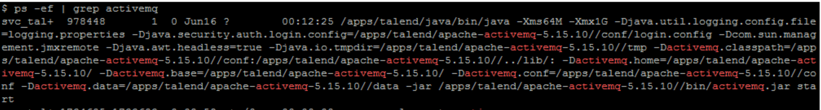

- Disk Usage Alert for the /apps/talend File System. If this FS cross 85% of space, there should be an alert sent for the same.

Startup and Shutdown Procedure:

Starting up the Talend RE Services:

Below would be the steps for starting the Talend Remote Engine services:

        - Login to the respective server with your ID and then do a sudo to svc_talend account as per the command – sudo su – svc_talend
        - Navigate to the /apps/talend/re/bin/ path and then execute the start script as per the command - ./start
        - To validate whether the services started and running fine or not, we can execute the status script in the same path and the output should be as follows:

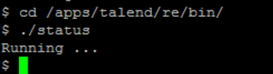

        - Else, we can also validate the services by checking for the process state as per below screenshot. If the process is active, we’ll get the output as follows:

Stopping the Talend RE Services:

Below would be the steps for stopping the Talend Remote Engine services:

        - Login to the respective server with your ID and then do a sudo to svc_talend account as per the command – sudo su – svc_talend
        - Navigate to the /apps/talend/re/bin/ path and then execute the stop script as per the command - ./stop
        - To validate whether the services started and running fine or not, we can execute the status script in the same path and the output should be as follows:

Insert Not Running Screenshot Here

        - Else, we can also validate the services by checking for the process state as per below screenshot. If the process is not active, we’ll get the output as follows:

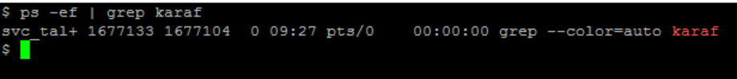

        - Note: We can also login to TMC and Navigate to the Engine section of the respective environment and if the Remote Engines are in Paired Status, then the RE is paired and is in running status. Else it is not.

Application Maintenance:

User Access Management:

General Troubleshooting:

RE Services are Not Active:
    - Login to TMC and check whether the status for the RE is in Paired or Not Paired.
    - Then login to that server and Navigate to the /apps/talend/re/bin path and execute the status script to check whether the services are active or not. If the Output is Not Running… then we can confirm that the RE services are down and needs to be started
    - Additionally, the logs for troubleshooting the RE would be available in the /apps/talend/re/data/log path. Karaf.log, management.log and wrapper.log are the main logs which we would need to use for troubleshooting purposes, along with the others mentioned below

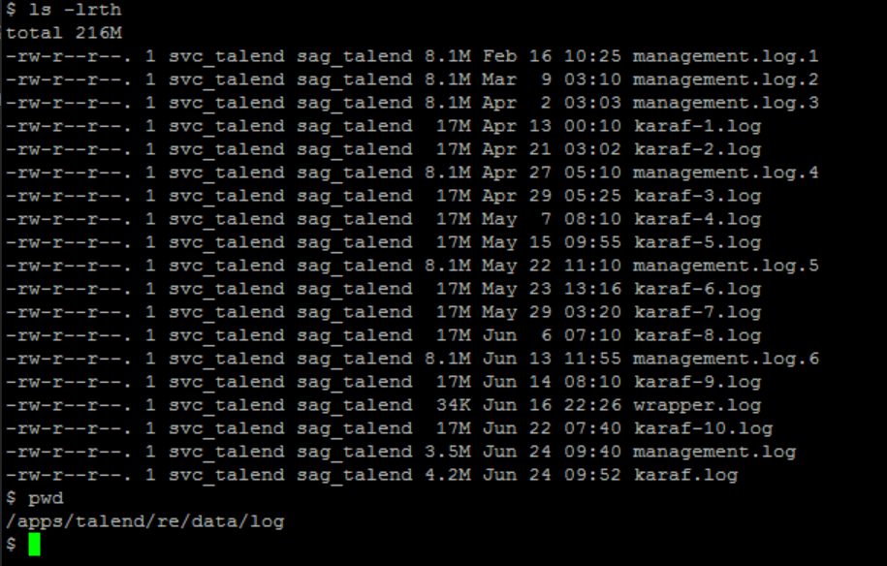

Troubleshooting the Job Specific Logs:
    - The Logs for the jobs would be readily available in the TMC under the Operations Tab for that specific job.
    - If we would like to troubleshoot in detail with respect to any job specific logs, we would need to navigate to the server in which the job was run and then navigate to /apps/talend/re/TalendJobServersFiles/jobexecutions/logs path. Here there will be separate folders for every job execution in the format YYYYMMDDhhmmss_<Hash Value>. We can execute below mentioned command to drill down to the respective job folder of choice

Command: grep -r "<Job Name>" | awk -F'/' '{print $1}' | sort -u

    - Here we will be having stderr.log (Containing all the warning/error messages depending on the error logging specified for the job) and resuming.log (Containing all the context values/parameters that were used for the job)

User Not able to login to TMC or Server:
    - Write about steps to be taken for this
Opening Ticket/Case with the Vendor:
    - For any additional support required to troubleshoot the issues specific to the talend environment, we can open a support ticket/case with the vendor as follows:
    - Write about steps to raise a ticket with vendor with screenshots

Ticket Criticality:
- For Production Environment – Blocker/Severe
- For Test Environment – Severe/Major
- For Development Environment – Severe/Major/Minor (This depends on the type & criticality of the issue)

